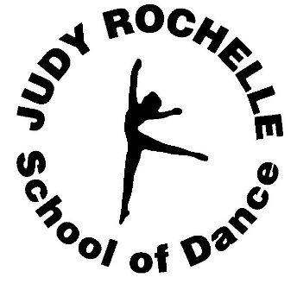
Judy Rochelle School of Dance
Registration Form 2017-2018

Please fill out the form, check the classes you would like to register for, and provide your $25 registration fee. The registration fee decreases by $5 for the second child, $10 for the third child and no registration fee for additional children.

Student’s Name: _______________________ Age: _________ D.O.B: _________ Grade: ______

Parent/Guardian’s Name: __________________________ E-Mail: ____________________________

Mailing Address: _______________________________ City: _____________ Zip: _______________

Primary Phone: ______________________ Secondary Phone: ___________________

Emergency Contact Name: ________________________ Emergency Phone: ___________________

Student School: _________________________________ Sports: ____________________________

Previous Dance Training: ______________________ Yrs: __________ Location: ______________

Classes:
Mommy and Me Class (18 months-2 yrs) (30 min/week) ($38 mth) {Mon. 5:30-6:00} ____________
Pre-School Dance Combo (2.5 yrs-4yrs) (1hr/week) ($48 mth) { Mon. 6:00-7:00} (Tues. 4:30-5:30}
____________________________________________________________________________________
Dance Combination (gr. K,1,2) (1hr/week) ($48 mth) {Mon. 4:30-5:30}________________
Dance Combination (gr. 2,3,4) (1hr/week) ($48 mth) {Tues. 6:00-7:00} _______________
Beginner Clogging (gr. 2 and up) (30 min/wk) ($38/mth or $10 add on) {Tues 5:30-6:00}__________
Beginner Tumbling/Acro (3 yrs- 3rd grade) (1 hr/week) ($38/mth) { Tues 4:00-5:00}______________
____________________________________________________________________________________
Jr. Dance Combination (gr. 5-7) (1hr 30min) ($58 mth) {Wed. 4:00-5:30} ______________________
Jr. and Sr. Clogging (gr.5-12) (30 min/wk) ($38 mth or $10 add on) {Wed. 5:30-6:00}______________
Senior Dance Combination (gr.8-12) (1hr 30min) ($58 mth) {6:30-8:00}_______________________
Jr./Sr. Pointe (30min/wk) ($38 mth or $10 add on) {Mon. 7:00-7:30}__________________________
Hip Hop (gr. 4 and up) (30 min/wk) ($38 mth or $10 add on) {Wed. 6:00-6:30}_________________
____________________________________________________________________________________
Adult Dance Combo (1 hr/week) ($30mth w/dancer/ $35 adult only) _____________________
Sr. Hip Hop (gr.7-12) (30 min/wk) ($38 mth or $10 add on) {Sat TBA}_____________________
Praise and Worship (any age) (1 hr/wk) ($38 mth or $10 add on) {Sat. TBA} ________________
____________________________________________________________________________________
Tumbling Tuesdays: Beginner (age 3-3rd grade) $38/mth_______________
Intermediate (gr.4-8) $38/mth___________________
Advanced Acro (Pending Instructor Approval): $38/mth__________________
(For Office Staff Use Only)
Shoes and Supplies Order Form:

Shoes: | Size: | Leotards: | Size: | Tights: | Size: | Pants/Shorts | Size:
Ballet
Tap
Jazz/Hip Hop

T-Shirt: __________________________

